**Insurance Renewal System**

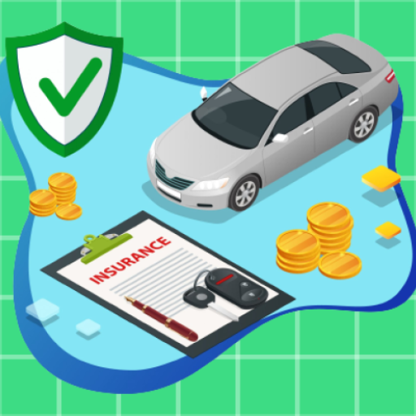

**E-Project**

**Group Members**

|  |  |
| --- | --- |
| Student Name | Enrollment No |
| Mr.Hamza Haroon | Student1276643 |
| Mr. Hassan Mujtaba | Student1311640 |
| Mr. Muhammad Wahaj | Student1312214 |
| Mr. Furqan-Ur-Rehman | Student1311432 |
| Mr. Farzam Ahmed | Student1312165 |

**Faculty: Miss Tooba Khawar**

**Batch Co-Coordinator: Miss Ariba Ali**

**Batch: 2104B1**

**Curriculum: OV-ACCP-PRIME (6740)**

**Acknowledge**

We would like to express our special thanks to our teacher (Miss Tooba Khawar) as well as our institute (Aptech) who gave us golden opportunity to do this wonderful project on this topic (Insurance Renewal System), which also helped us a lot of research and we came to know about so many new things for which we all are thankful to them.

Secondly, we should also like to thanks our batch coordinator (Miss Ariba Ali) who helped us a lot in finalizing this project within the stipulated time frame.

**Review**

Insurance Renewal System is an online e-Insurance Renewal System where any user can easily renew your car’s insurance yourself, without any facing hurdles, as well as they also registered themselves with this app.

Moreover, they can download registered insurance info via pdf format. The purpose of this app is to facilitate those people who like to renew their car’s insurance.

**Requirement Specification**

This app is to be created based on the following requirements.

* A database should be created that holds the details of the cars, renewal insurance, and policy details.
* The users who are registered with the app will alone be able to fetch and see the details of the registered insurance.
* The user also should have the rights to download the details via pdf.
* The user can view the premium policy and its amount.

**Hardware/ Software Requirements**

**Hardware**

* + - * Android mobile with a minimum version 2.2.
      * The processor is not less than 500MHZ.
      * RAM is not less than 2048MB,
      * SD card with a minimum of 512MB.
      * Resolution is not less than 480*800pix.

**Software**

Use software as per your requirement.

* Windows OS/JAVA/Android SDK/Notepad/SQL/Android 2.2 or Later.

**Process Diagram**

**Buy Insurance Screen**

**Insert Screen**

**Home Screen**

**Payment Screen**

**Check Insurance Screen**

**Splash Screen**

**Task Sheet**

|  |  |  |  |
| --- | --- | --- | --- |
| S# | Task | Team Member Name | status |
| 1. | Analysis | Hassan Mujtaba  Muhammad Wahaj  Furqan ur Rehman  Muhammad Hamza | ✓ |
| 2. | Design | Hassan Mujtaba  Muhammad Wahaj | ✓ |
| 3. | Development | Hassan Mujtaba  Muhammad Wahaj  M. Hamza  Furqan ur Rehman  Farzam Ahmed | ✓ |
| 4. | Documentation | Muhammad Hamza  Furqan ur Rehman | ✓ |
| 5. | Finalization | Hassan Mujtaba  Muhammad Wahaj  Muhammad Hamza  Furqan ur Rehman  Farzam Ahmed | ✓ |

**SUBMISSION CHECKLIST**

|  |  |  |  |
| --- | --- | --- | --- |
| S.no | List of items | Remarks | Comments |
| **1.** | Do Pages Linked  together | **Yes** | ✓ |
| **2.** | Crud Operations(Insert, Read) | **Yes** | ✓ |
| **3.** | Database Connection | **Yes** | ✓ |
| **4.** | Project Zip File | **Yes** | ✓ |

**“SCREEN SHOTS “**

**Splash Screen**

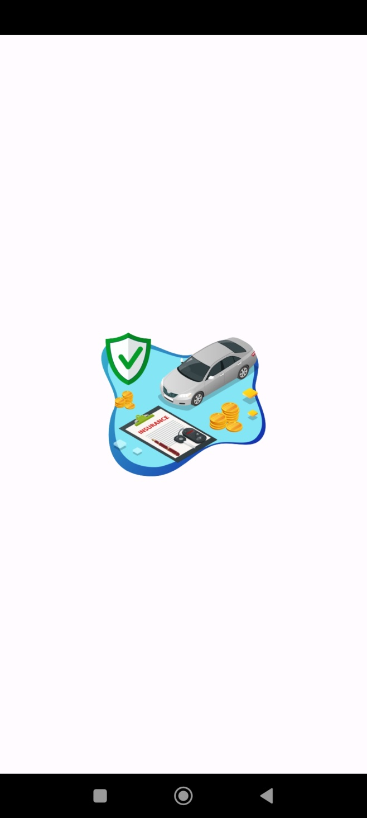

**Main Activity/Home Page**

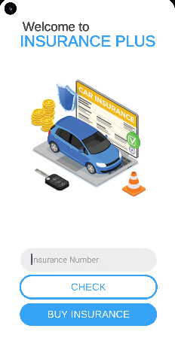

**Buy Insurance Activity/ Page**

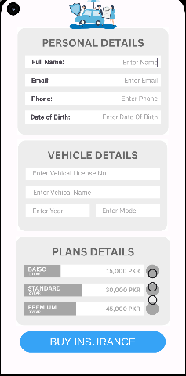

**View Details Activity/ Page**

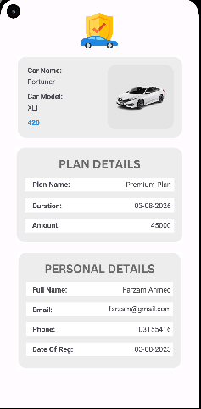

**Payment Details Activity/ Page**

